Module 09 – Fixed Charge Problem

Exploratory Data Analysis

*In this section, you should perform some data analysis on the data provided to you. Please format your findings in a visually pleasing way and please be sure to include these cuts:*

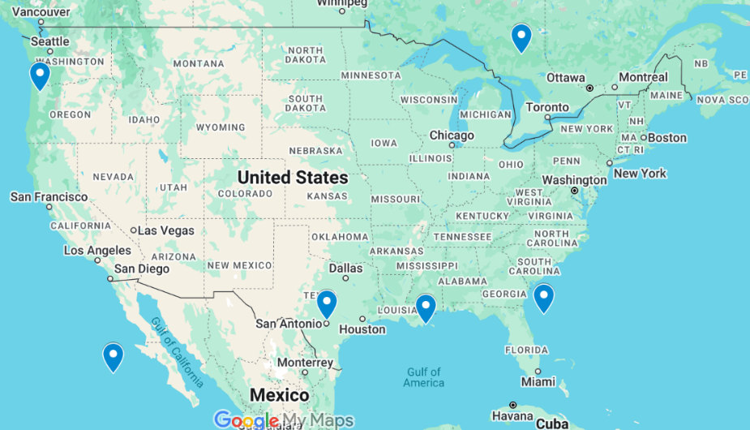

Model Formulation

*Write the formulation of the model into here prior to implementing it in your Excel model. Be explicit with the definition of the decision variables, objective function, and constraints.*

MAX: 7.18 X11 + 25.08 X12 + 15.28 X13 + 49.86 X14 + 34.48 X15 + 24.13 X16

+ 6.41 X21 + 19.55 X22 + 20.81 X23 + 51.01 X24 + 39.05 X25 + 29.66 X26

+ 29.76 X31 + 55.72 X32 + 15.36 X33 + 28.38 X34 + 13.00 X35 + 6.51 X36

+ 6.72 X41 + 19.24 X42 + 21.12 X43 + 51.44 X44 + 39.36 X45 + 29.97 X46

– 1026 Y1 – 1328 Y2 – 1698 Y3 – 1395 Y4

X11 + X21 + X31 + X41 = 799 🡪 Smores Summit demand

X12 + X22 + X32 + X42 = 913 🡪 Starburst Starlit Skies demand

X13 + X23 + X33 + X43 = 792 🡪 Sugar Swirl Spires demand

X14 + X24 + X34 + X44 = 846 🡪 Taffy Tundra demand

X15 + X25 + X35 + X45 = 866 🡪 Peanut Butter Parlor demand

X16 + X26 + X36 + X46 = 661 🡪 Rock Candy Ridge demand

X11+X12+X13+X14+X15+X16 – 4877 Y1 ≤ 0

X21+X22+X23+X24+X25+X26 – 4877 Y2 ≤ 0

X31+X32+X33+X34+X35+X36 – 4877 Y3 ≤ 0

X41+X42+X43+X44+X45+X46 – 4877 Y4 ≤ 0 (Linking constraints)

*Implement your formulation into Excel and be sure to make it neat. This section should include:*

* *A screenshot of your optimized final model (formatted nicely, of course)*
* *A text explanation of what your model is recommending*

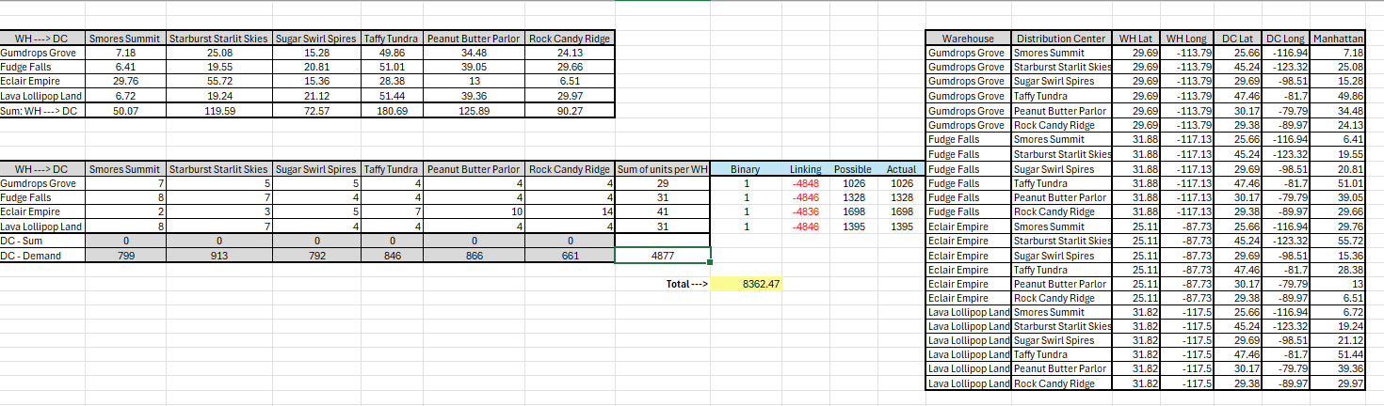

The model is recommending that all four warehouses, Gumdrops Grove, Fudge Falls, Éclair Empire, and Lava Lollipop Land, should be open and ship a small number of units to each distribution center (DC) in a way that meets each DC’s demand totaling 4877 units. This allocation of units minimizes total cost by balancing Manhattan shipping costs with warehouse setup costs to get a minimal cost of $8,362.47

Model with Stipulation

*Please copy the tab of your original model before continuing with the next part to avoid messing up your original solution.*

SCENARIO 1:

Y1+Y2+Y3+Y4 ≤ 1 🡪 new “open-at-most-one” constraint

All Yi binary, Xij ≥ 0.

What changed? - By capping Yi≤1, the model is forced to pick the one facility with the single lowest combined setup + shipping cost and ship all the demand from that one. The total cost increases quite a bit since distant Distribution Centers must now be served from farther away, and distances are not optimal.

SCENARIO 2: Cost per unit shipped increased from $1 to $30

MAX: – (30\*7.18) X11 – (30\*25.08) X12… – (30\*29.97) X46

– 1026 Y1 – 1328 Y2 – 1698 Y3 – 1395 Y4

S.T.: (same demand & linking constraints as before)

Y1+Y2+Y3+Y4 <= 4 (no change – up to 4 can still open)

What Changed?

Multiplying each shipping constraint by 30 makes unit‐distance costs much greater than the fixed setup fees. The model still opens all four warehouses but now assigns each distribution center to its closest warehouse with no split shipments. This, in turn, reduces longer transports and transport costs at the expense of increasing fixed cost by using more fixed cost sites.

*Please perform 2 out of the 3 scenarios below with a short text description on what changed:*

1. *Instead of only being able to open 2 warehouses, what happens to our objective function when we only can open 1 warehouse?*
2. *Right now, we have $1 per unit shipped over the distance between the warehouse and the DC. What happens to our objective function when we increase this to $30? Does your DC assignment change at all?*